Experiment 11: Perform Affine Transformation on an Image
Aim
To perform Affine Transformation on an image using Python and OpenCV.
Software Requirements
- Python 3.x
- OpenCV (cv2)
- NumPy
- Visual Studio Code / PyCharm / Jupyter Notebook
Procedure
- Install the required libraries using:
- Import the required libraries (cv2 and numpy).
- Read the input image using cv2.imread().
- Check whether the image is loaded successfully.
- Select three points from the original image.
- Select three corresponding points for the transformed image.
- Compute the affine transformation matrix using cv2.getAffineTransform().
- Apply the transformation using cv2.warpAffine().
- Display the original and transformed images.
- Press any key to close all image windows.
Python Code
import cv2
import numpy as np
# Read the image
image = cv2.imread("sample.jpeg")
if image is None:
print("Error: Image not found!")
else:
rows, cols, ch = image.shape

# Select 3 points from original image
pts1 = np.float32([[50, 50],
[200, 50],
[50, 200]])
# Select corresponding 3 points in transformed image
pts2 = np.float32([[10, 100],
[200, 50],
[100, 250]])
# Create Affine Transformation Matrix
matrix = cv2.getAffineTransform(pts1, pts2)
# Apply Affine Transformation
transformed = cv2.warpAffine(image, matrix, (cols, rows))
# Display images
cv2.imshow("Original Image", image)
cv2.imshow("Affine Transformed Image", transformed)

cv2.waitKey(0)
cv2.destroyAllWindows()
Output
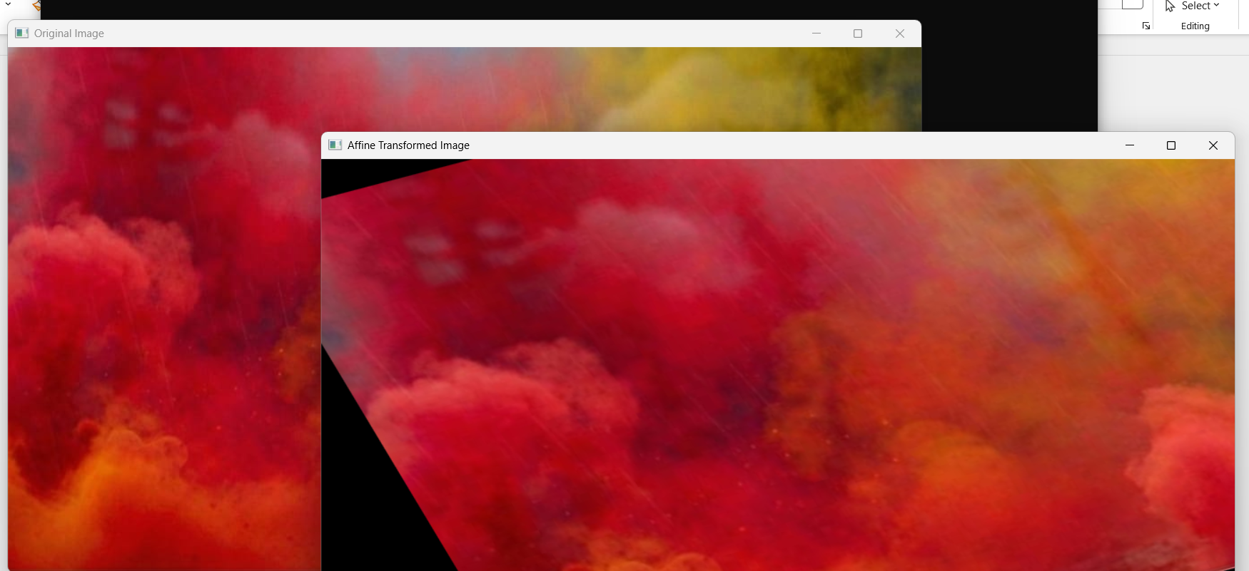
Result
The affine transformation was successfully performed on the input image using Python and OpenCV. The transformed image was displayed by applying the affine transformation matrix generated from the selected corresponding points.

